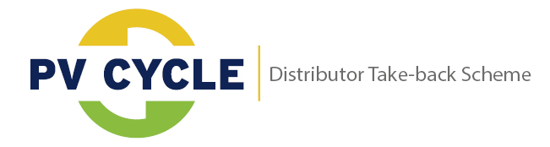

To be completed and presented by the customer at the delivery in 2 copies, one for the customer and one for the DCF

- SELECT ORIGIN OF DISCARDED PV PANELS

Household
Distributor member of PV CYCLE DTS (Distributor Take-back Scheme)

- COMPLETE THE TABLE BELOW IN CASE OF DISTRIBUTOR ORIGIN

Distributor Company Name:
DTS Identification number:
Address:
ZIP Code, City:
Contact person:
Telephone Number:
Email:

- INDICATE AMOUNT, TECHNOLOGY AND WEIGHT OF DISCARDED PV PANELS

Amount of panels
   | Crystalline silicon |  |  | Amorphous/micromorph silicon
   | Laminates /  Flexible modules |  |  | Concentration PV
   | CI(G)S |  |  | CdTe
Weight in kilograms:
Reason for disposal:
  End of use
  Transport or installation damage
  Material defect
  Other
General status of the panels:
  Intact
  In pieces or pieces removed
  Other (broken, heat point, delaminated)
Date & Signature:

- TO BE COMPLETED BY THE DCF:

 | Acceptance: |  | Rejection:
Burned by fire and mixed with construction and demolition waste
Other: (Solar thermal panels, inverters, batteries, …)

Receipt by (name):
Date of acceptance:
Number of panels: |  | Signature and stamp:
Internal no. of delivery:

