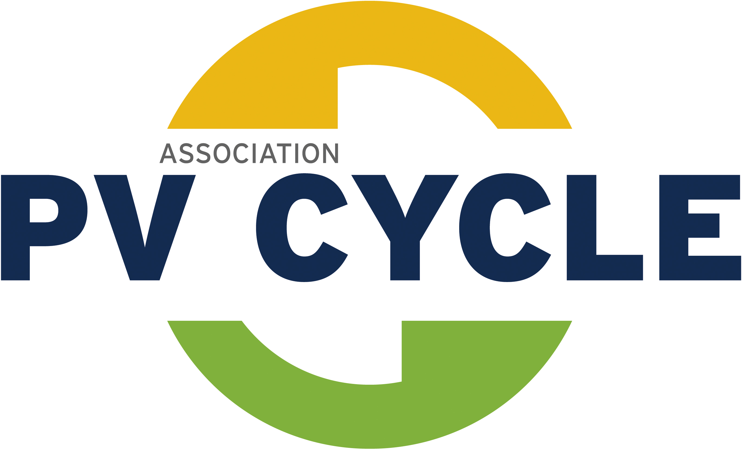
Request for quotation pick up and treatment
To be sent by email to PV CYCLE at operations@pvcycle.org

Company Name*:
Pick- up address*:
ZIP Code, City, Country:
Name of the contact person at the place of pick up*
Telephone Number*:
Email*:
Technology*:  (write the number of modules per technology in the related box)
  May be packed together:
   | Crystalline silicon |  |  |  | Amorphous/micromorph silicon
  May be packed together
   | Flexible modules |  |  |  | Concentration PV
  May be packed together:
   | CI(G)S |  | CdTe (except First Solar and Abound Solar)
Manufacturer (s) or brand’s name to be found on the module’s label*:
Date of purchase:
(if known)
Packaging:
TYPE of packaging accepted: Pallet**,Wood box, Original package
Number of pallets/wood box/original package*:
Weight in kilograms*: |  | Size in centimeters* (WxLxH):
Weight in kilograms*: |  | Loading meters:
Weight in kilograms*: |  | Are the pallets stackable*?
Forklift available at the place of pick up*
  yes
  no
Reason for disposal:
  End of use
  Transport or installation damage
  guarantee cases
  Other (by fire cases please contact directly PV CYCLE)
General status of the modules:
  Intact
  In pieces or pieces removed
  Other (broken, heat point, delaminated)
Date & Signature*:
* Mandatory fields. Incomplete forms are not processed.
**only one way pallets are to be used. PV CYCLE provides no exchange of EUR pallets.

